Totaal Software



Tutorial
June 19th 2000

PRELIMINARILY

Early, incomplete version
Final version to be released later this week

Case example 2
Constructing a new file 2
Stage race organisation 3
Entering settings 3
Adding full stages 4
Adding half stages 4
Teams 6
Competitors 7

This document consists of a tutorial which makes you familiar with the basics of using StageRace.
By means of a practical example, you’ll be guided through all the settings that apply.

Case example

The Society of Cycling in Lion, France, decides to do a four days cycling event for youth riders, during the Easter weekend, called ‘les Etapes Pâques’.

The event starts off with a short stage on Friday night, consisting of ten rounds of four kilometres each. On Saturday morning there is a time trial over 6,2km. And then a big stage from Lion to St.-Gerlach, over 89,3km.
Sunday afternoon there is a stage from St.-Gerlach to Riagé over a distance of 95,2km. And on Monday morning the final is ridden between Riagé and Lion over 75,0km.
There will be a separate regional riders classification, sponsored by the local brewery, Lion Malt.

Constructing a new file

Through New in the File menu, construct a new file. A file name will be asked for, ‘Pâques’ will do. Also chose the appropriate folder for this file to be stored. Pay attention to this folder, as it will also be the folder were all the classification files will be generated in (as html files).

Stage race organisation

Note that StageRace is designed to make a division into (the moment of execution of) the following tasks:
- Configuring of an event. This can be done in the days preceding to the event, in cooperation with an organization representative.
- Utilisation of an event. This takes place during the happening of the various stages, in cooperation with the members of the jury which are present.

An event consists of a number of full stages or days.
Every full stage consists of one or several half stages. This means that also for a day on which only one stage takes place, a full stage with only one half stage within will be constructed.
The entire event will be displayed within StageRace as a tree structure. At the top level one finds the main event, information on the main event, the competitors and the teams.
The event consists of one or several stages. Every stage consists of one or several half stages. The main event as well as every part of it can consist of one communiqué. Half stages can also consist of entities like sprints and sign-outs.
A half stage can appear in different forms, namely a normal half stage and a time trial.

Entering settings
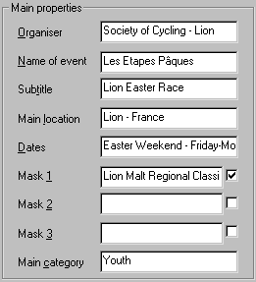
Through Settings in the Configure menu, you can alter all the settings for this race. On the tab sheet Main properties you should enter the information as in the provided illustration, considering our case example.
Confirm your new settings with OK.

Because we want the Mask 1 to correspond to our separate regional riders classification, we fill the title in and check the box next to Mask 1 to enable this masked classification.

Adding full stages

To add a stage, chose Insert in the Configure menu. When you select Full stage... the date of the new stage will be asked for.
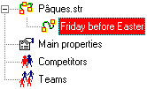Enter for instance Friday before Easter and confirm by OK.
The new stage will be added to the tree view.
Repeat this for the three other days as well. Note that the two events on Saturday (the time trial and the big race over 89,3km) are half stages of the same full stage. Ergo, for the Saturday, you only add one full stage!

Adding half stages

Even if a full stage only consists of one half stage, this half stage has to be inserted explicitly into the full stage.
So, for every half stage, you select the appropriate full stage in the tree view and select Half stage... through Insert from the Configure menu.
StageRace will then produce a dialog screen consisting of four tab sheets, to make it possible to enter all data being part of that particular half stage. Since sprints and bonuses will be discussed later, only the Stage settings are discussed here.

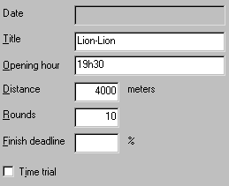Normal half stage

This is not a time trial, obviously, so make sure that Time trial is checked off.
There are four boxes to be filled in, where our case example can be considered.
Date can not be provided by you, since this will be taken from the date of the full stage, as entered earlier in this tutorial.
Finish deadline was not implemented at the moment this tutorial was drawn up.
Confirm this dialog with OK.
The first stage (and its half stage) are finished for now.

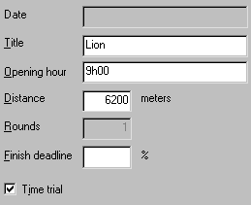Time trial

Within the second full stage there are two half stages. Note that they have to be added in the right order, because no half stages can be inserted afterwards.
So, insert a half stage in the second full stage and complete the Stage settings tab sheet again, as it is showed in the illustration.
Because this is a time trial, you have to select the Time trial check box. Whatever is in the Rounds box doesn’t matter, because the number of rounds of a time trial is always one.

Add all the other half stages as well. Note that with city-to-city stages, the number of rounds should be one.
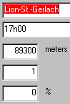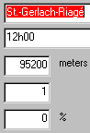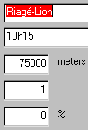
Your tree should look like the one below, now. If it doesn’t, note that you can remove items by selecting them and use Delete... from the Configure menu. Use Configure selection... from the same Configure menu to reconfigure the selected half stage.

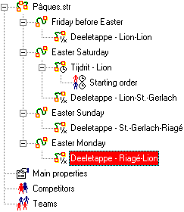

Teams

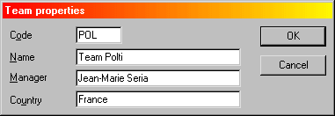By double-clicking Teams in the tree view, as well as by choosing Teams... from the Edit menu, you can access the teams list which is probably empty at the moment.
Click new and enter team data. Note that the team code should be an unique code. This will by evaluated by StageRace.
Confirm with OK. The team will appear in the teams list now.
Add a few more teams.

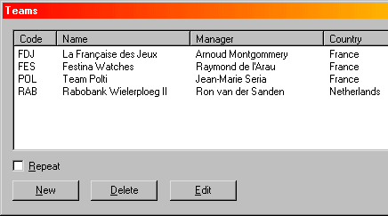If you want to edit or delete one of the added teams, just select it and click on the appropriate button.

Competitors

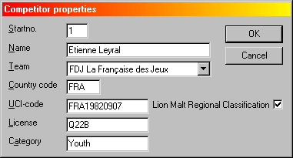The competitors list works quite similar. Double-click Competitors or select Competitors... from the Edit menu.
Add some competitors. Note that the check box on the right corresponds to the regional riders classification as configured at the main properties of the event. Also note that the startno. should be an unique number. This will be evaluated by StageRace.

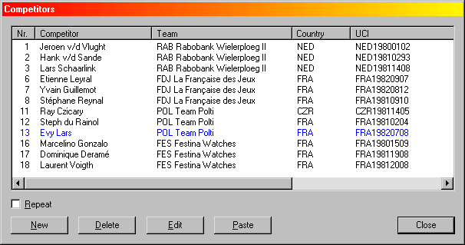
The competitors will appear in the competitors list. If you want to edit or delete one of the added competitors, just select it and click on the appropriate button.

